Name Catherine Pollock Date 11/20/14
Laboratory 12: Cover Sheet

Section 1001

Place a check mark in the Assigned column next to the exercises your instructor has assigned to you. Attach this cover sheet to the front of the packet of materials you submit following the laboratory.

Activities | Assigned: Check or list exercise numbers | Completed
Implementation Testing | ✓
Programming Exercise 1 | ✓
Programming Exercise 2 | ✓
Programming Exercise 3 | ✓
Analysis Exercise 1 | ✓
Analysis Exercise 2 | ✓
 | Total

Name Catherine Pollock Date 11/20/14
Laboratory 12: Analysis Exercise 1

Section 1001
[Please reference the lab book for the full description of this problem.] The following graph, for example,

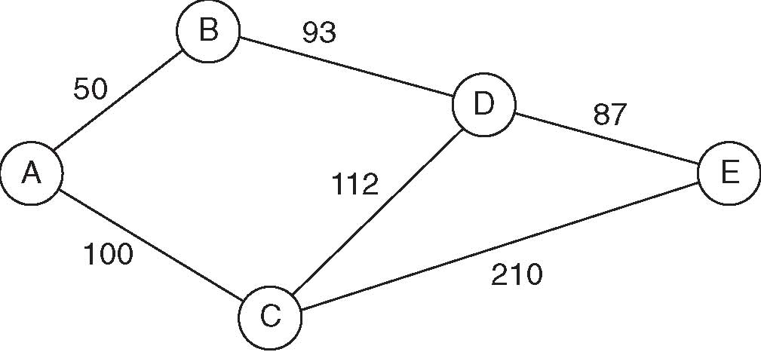
yields the augmented path matrix shown below.

Vertex list |  | Path matrix (cost|second vertex on shortest path)
Index | Label | From/To | 0 | 1 | 2 | 3 | 4
0 | A | 0 | 0|0 | 50|1 | 100|2 | 143|1 | 230|1
1 | B | 1 | 50|0 | 0|1 | 150|0 | 93|3 | 180|3
2 | C | 2 | 100|0 | 150|0 | 0|2 | 112|3 | 199|3
3 | D | 3 | 143|1 | 93|1 | 112|2 | 0|3 | 87|4
4 | E | 4 | 230|3 | 180|3 | 199|3 | 87|3 | 0|4

Entry (0,4) in this path matrix indicates that the cost of the shortest path from vertex A to vertex E is 230. It further indicates that vertex B (the vertex with index 1) is the second vertex on the shortest path. Thus the shortest path is of the form AB...E.

Explain how you can use this augmented path matrix to list the vertices that lie along the shortest path between a given pair of vertices.

This augmented path matrix can be used to list the vertices that lie along the shortest path between a given pair of vertices through the use of the indication of the index of the vertex along the shortest path. Along with the cost of the path, each data value includes the index of the second vertex on the shortest path. To list them, one could create an outer iterator that loops through each data row, and an inner iterator that loops though each data column, and prints the start and end entries, along with the one listed on the ending entry.

Name Catherine Pollock Date 11/20/14
Laboratory 12: Analysis Exercise 2

Section 1001

Give an example of a graph for which no proper coloring can be created using less than five colors (see Programming Exercise 2). Does your example contradict the Four-Color Theorem?
A graph that would need five colors would be an extremely dense graph, where edges would cross one another. A graph that would be incorrectly colored with only four colors would need a fifth, and would not support the Four-Color Theorem. Page 175 of the lab book states that the Four-Color Theorem is only valid for graphs that have edges that do not cross. An extremely dense graph with many connections would call for more colors, since the colors can’t conflict. For this reason, the Four-Color Theorem could not be applied.

